Json server creates a fake REST (Representational State Transfer ) service using Web Api

Using the db.json we can use the services good thing is it can be used in watch mode.

Db.json file contains

{

"Incidents":[

{

"id":1,

"Incidentid":1234,

"percentage":100,

"comment":"Second task",

"Applicationname":"CQA",

"createddate":"02-11-2017",

"Modifieddate":"02-12-2017"

},

{

"id":2,

"Incidentid":67890,

"percentage":20,

"comment":"Second task",

"Applicationname":"CQA",

"createddate":"02-11-2017",

"Modifieddate":"02-12-2017"

}

]

}

The thing to be noted is while accessing the url you can fetch all the values within the parameters as

<http://localhost:3000/Incidents?percentage=100>

it fetches all the values of the percentage = 100 if you don’t know the values of the columns then also we can use it using the q as the parameter

<http://localhost:3000/Incidents?q=100>

Using Postman :

The postman is used to fake the http calls to the web api you can get , delete , post and put requests and many other it can be used as the google chrome extension also.

**GET** Request :

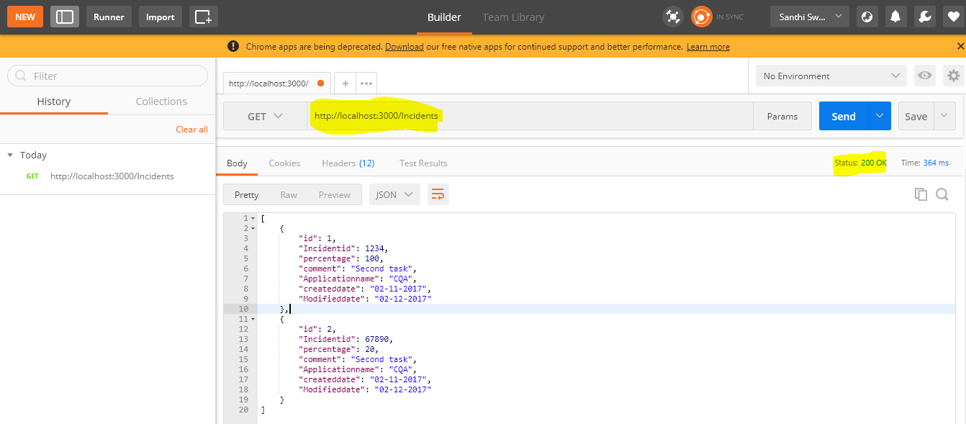

**In the post request I have forgot the url which I have entered later paste the url and take care that ID shouldn’t be entered while sending the json object as it will create the id now we would using the get request again and observe the Incidents list**

**Post Request :**

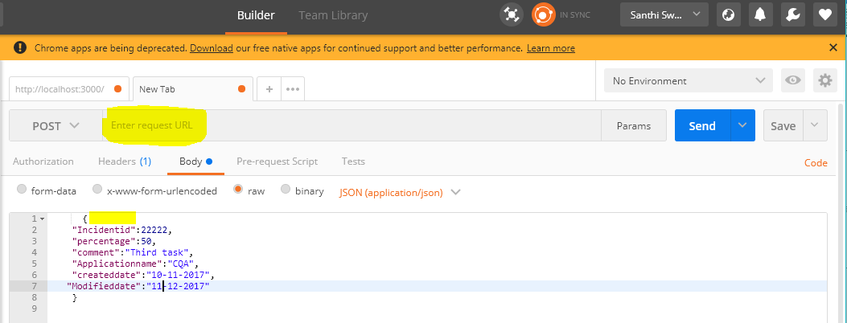

**After adding the third object….**

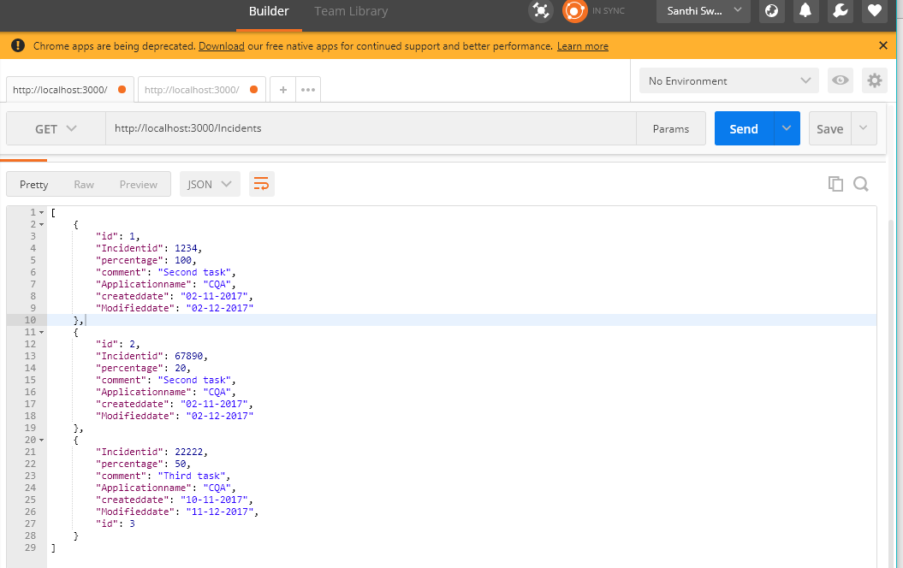

Put Requeset :

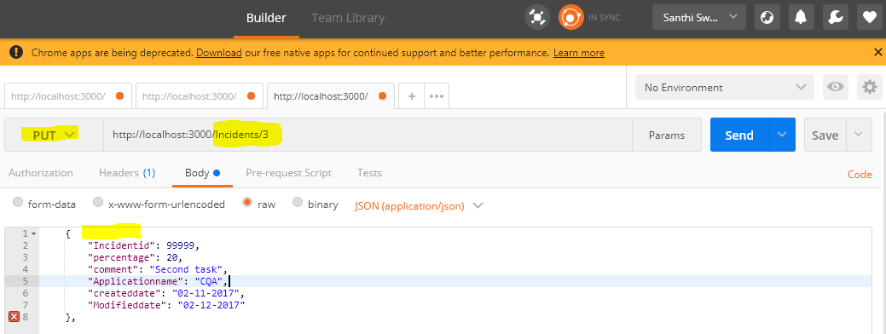

The same applies for the post request we will not use the id and we need to give the id in the url , observe in the above screenshot in the line 8 there is a cross mark indicating a extra comma which it is saying an error so I got the bad request error for 400 so we need to remove it and put the request again then it is success



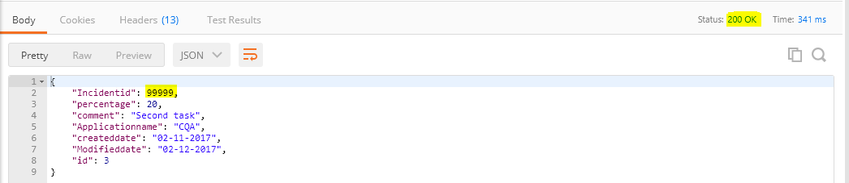

**Faker : npm install faker**

Now we have seen the testing of the webapi but we also can generate the fake web api services within minutes using the faker by installing it through npm there is a static library through which we can create random numbers and random strings using the static db in the faker we will create a script using the faker library in a js file like shown below and we shouldn’t be forgetting the

module.exports = fuctionname

as it will not generate the fake web api once we create the generate function we will run it through npm using the **json-server employee.js** we will pass the employee.js file we created with below content as a parameter to generate the employee list of 50.

var faker = require('faker');

function GenerateEmployees(){

var Incidents = [];

for(var Id=1;Id<=50;Id++){

Incidentid = faker.random.number(100000,100000),

percentage = faker.random.number(1,100),

createddate = faker.date.past(),

Modifieddate = faker.date.past(),

comment = faker.lorem.sentence()

Incidents.push({

"Id" : Id,

"Incidentid":Incidentid,

"percentage":percentage,

"comment":comment,

"Applicationname":"CQA",

"createddate":createddate,

"Modifieddate":Modifieddate

})

}

return { "Incidents" : Incidents}

}

module.exports = GenerateEmployees

For Faker library for help we can go to https://github.com/marak/Faker.js/

